Cafeteria Monitor Badges
DIRECTIONS:
1. Print pages 2-3 double-sided, in color, and preferably on cardstock
2. Laminate the sheet and use scissors to cut out each badge
3. Use a hole punch to make two holes in the badges; one at each corner, at the top
4. Tie a length of string through the holes, long enough to fit around student’s head.
NOTE:
It’s important to know whether or not your school is participating in the Organics Collection program from the NYC Departments of Sanitation and Education. To confirm this, you can visit your cafeteria, or check the list online at www.schools.nyc.gov/sustainability. If your school does not collect organic material (i.e. food scraps and food-soiled paper products), do not prepare the Organics Monitor badge, and instruct your Landfill Monitor that food scraps and food-soiled paper like napkins, goes in the trash.

RECYCLING MONITOR
- Remind students that all hard plastics go into the blue bin. If you can ball-up a piece of plastic in your fist, it’s not a hard plastic.
- Empty cartons, bottles, cans, and plastic cups, forks and spoons, and aluminum foil, all go in the recycling bin.
Always say “please” and “thank you”

POUR MONITOR
- Remind students to empty leftover liquids from drink containers into the liquids bucket.
- Remind students to pour liquids close to the bucket so it doesn’t splash on other people.
Always say “please” and “thank you”

ORGANICS MONITOR JOB
- Explain that all food scraps and compostable plates* go in the brown bin, along with napkins, brown paper bags, and empty cardboard boxes (such as Lunchables packaging).
- Help keep out all other materials, like ketchup packets and recyclables
Always say “please” and “thank you”

LANDFILL MONITOR
- Soft plastics also go into this bin.
- For non-organics schools: Explain that all food scraps and compostable plates go in this bin, and also all napkins and brown paper bags.
- Help keep recyclables out of the landfill bin.

Always say “please” and “thank you”

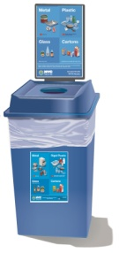
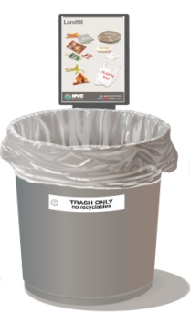
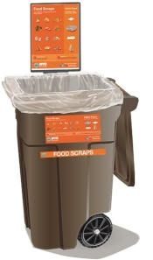
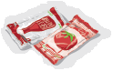
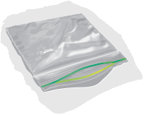
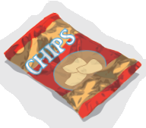
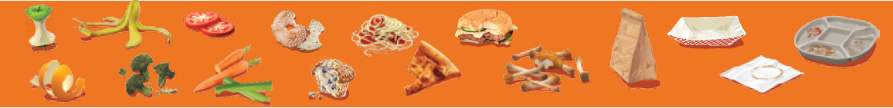
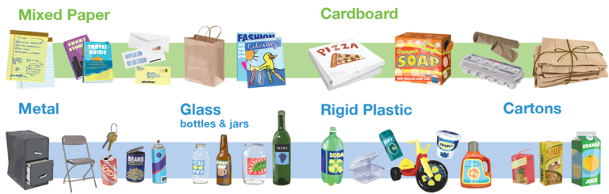
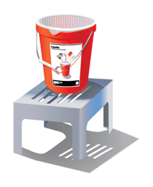
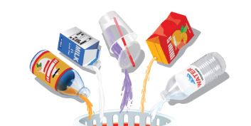

Recycling Monitor

Pour Monitor

Landfill Monitor

Organics Monitor

