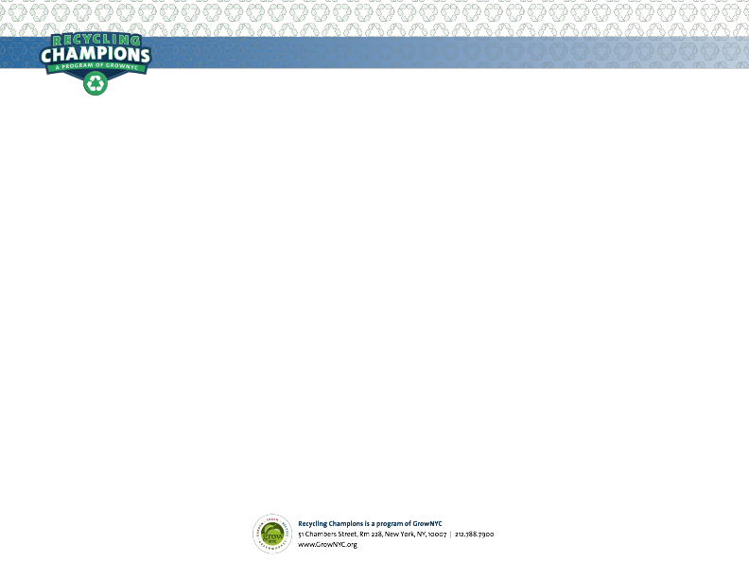

Dear Faculty & Staff,   
  
As you set up your classroom or office, please take notice of which bins you and your students will use for **paper recycling**, **metal/glass/plastic/cartons recycling**, and **trash**. Recycling in schools is more than just the law; it’s also a school expectation. The best part is it’s easy; here are some tips:   
   
• Keep bins together and close to the classroom door, or in a convenient place in the office.   
  
• Keep bins in the same place every day.  
 - This helps students develop good habits. It also helps custodians so bins can easily be emptied and returned to the same location.

• Recycling should be a classroom rule.

• If you need an additional bin, or more signage, please contact **[ENTER CONTACT]**

Review NYC’s Recycling Guidelines with your classroom, illustrated below:

Recycling has a big impact. It supports local jobs in and around NYC, saves money by reducing trash exports costs, and keeps our City clean and healthy. But NYC can do better – we only recycle half the paper we could. Every year we throw out 400,000 tons of recyclable paper, enough to fill the Empire State Building.

***Your School’s*** Sustainability Coordinator,

***[ENTER NAME]***

For additional resources, tools, and references, please visit:  
 • *The NYC DOE Sustainability Initiative*: www.schools.nyc.gov/sustainability  
 • *The NYC Department of Sanitation*: www.nyc.gov/recycles  
 • *GrowNYC*: www.grownyc.org/recyclingchampions