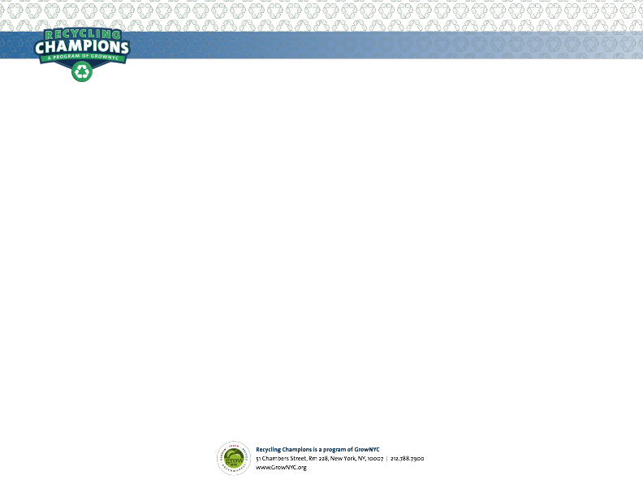

Dear Faculty & Staff,

On **[INSERT GOAL DATE]**, our school will begin requiring students to recycle in the cafeteria and will be launching this initiative through a ***Cafeteria Recycling Town Hall*.**

To make this launch a success, we need your help. Here’s how:

**[INSERT WHAT WILL BE ASKED OF TEACHERS FOR THIS DAY. IT COULD BE TO VOLUNTEER AS MONITORS IN THE CAFETERIA, OR TO REVIEW CAFETERIA RECYCLING WITH THEIR CLASSROOMS PRIOR TO LUNCH TIME]**

What will students are recycling in the cafeteria? Cafeteria recycling consists in sorting **Metal, Glass, Plastics and Cartons** accordingly with NYC’s guidelines in a separate waste stream. Recycling is easy, and with a little effort up front I know this is going to become an easy part of every school day.

|  |  |
| --- | --- |
| * milk cartons * juice cartons * plastic utensils * yogurt/desert cups * plastic beverage bottles | * plastic cups * take-out containers * aluminum foil * metal cans |

**Common Cafeteria Recyclables**

We’re confident that cafeteria recycling will have a positive impact on student’s behavior and our school’s culture. Recycling in the cafeteria is required by law, and has a huge positive impact on our City and planet. With students recycling more, we also hope to curb littering in the cafeteria and around the school.

We’ll keep you posted on progress, and thank you in advance for your support and encouragement.

***Your School’s*** Sustainability Coordinator,

***[ENTER NAME]***

For additional resources, tools, and references, please visit:  
 • *The NYC DOE Sustainability Initiative*: www.schools.nyc.gov/sustainability  
 • *The NYC Department of Sanitation*: www.nyc.gov/recycles  
 • *GrowNYC*: www.grownyc.org/recyclingchampions